- Watch the Terraform-05 video.
Completed
- Execute the script shown in the video.
Remote backends
State locking is used to lock the state file so that no other users can execute the state file at the same point of time.
Configure awsCreate & Copy the accesskeyPaste in the local machine.
# Configure AWS provider
provider "aws" {
region = "us-east-1" # Change to your AWS region
}

# Create S3 bucket
resource "aws_s3_bucket" "terra-bucket" {
bucket = "s3aleem007"
acl = "private"
}
Terraform init
Terraform apply
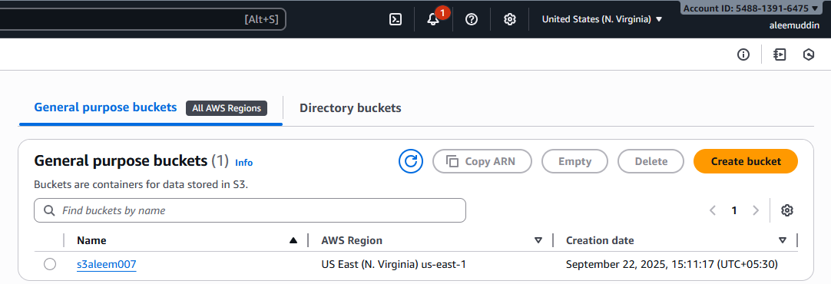

- resource "aws_dynamodb_table" "dynamodb-terraform-state-lock" {
- name = "terraform-state-lock-dynamo"
- hash_key = "LockID"
- read_capacity = 20
- write_capacity = 20

- attribute {
- name = "LockID"
- type = "S"
- }
- }
Terraform init
Terraform apply
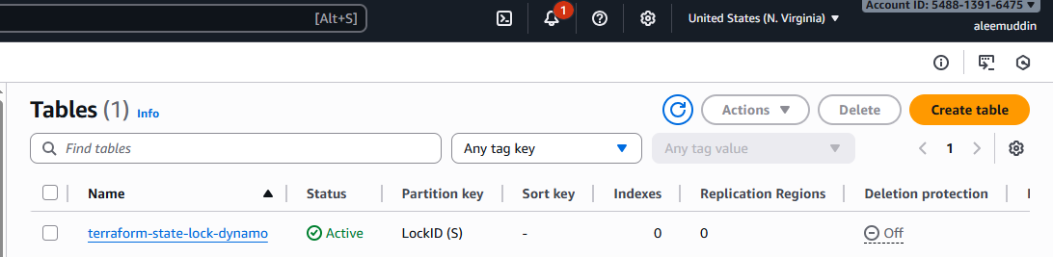
- Create one EC2 instance with httpd installed using a Terraform script.
- resource "aws_instance" "terra-server" {
- ami = "ami-0b09ffb6d8b58ca91"
- instance_type = "t3.micro"
- key_name = "Virginia"
- tags = {
- Name = "terra-server"
- }
- user_data = <<-EOF
- #!/bin/bash
- yum update -y
- yum install -y httpd
- systemctl enable httpd
- systemctl start httpd
- echo "<h1>Hello from Test-server</h1>" > /var/www/html/index.html
- EOF

- }
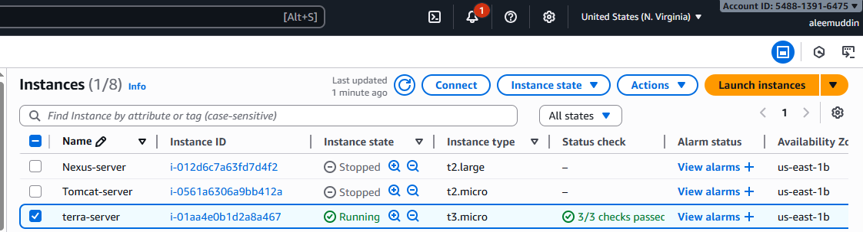
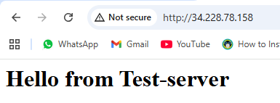
- Set up S3 as backend for task 3.
- # Configure AWS provider
- provider "aws" {
- region = "us-east-1" # Change to your AWS region
- }

- # Create S3 bucket
- resource "aws_s3_bucket" "terra-bucket" {
- bucket = "s3aleem007"
- acl = "private"
- }
Terraform init
Terraform apply

- Set up DynamoDB locking for task 3.
- resource "aws_dynamodb_table" "dynamodb-terraform-state-lock" {
- name = "terraform-state-lock-dynamo"
- hash_key = "LockID"
- read_capacity = 20
- write_capacity = 20

- attribute {
- name = "LockID"
- type = "S"
- }
- }
Terraform init
Terraform apply


